Structure of the excel file
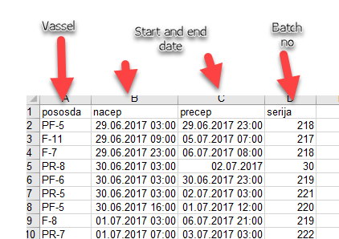

Reading the excel file, with the PowerPoint
Put the files in the same folder
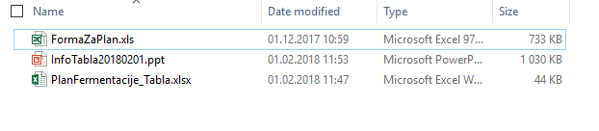
Open the PowerPoint file
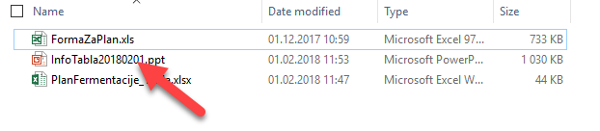
Start the presentation
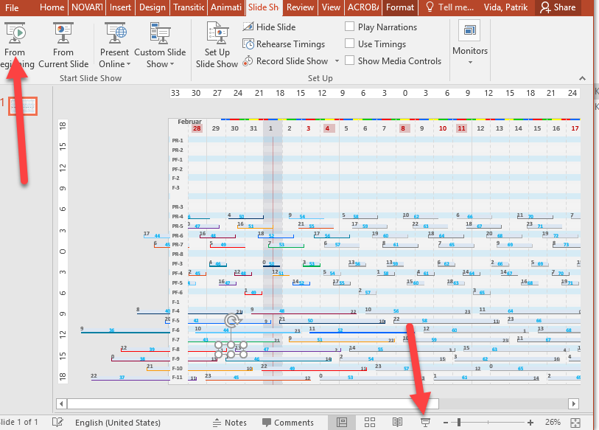

The presentation should refresh
If not click “Osvezi”
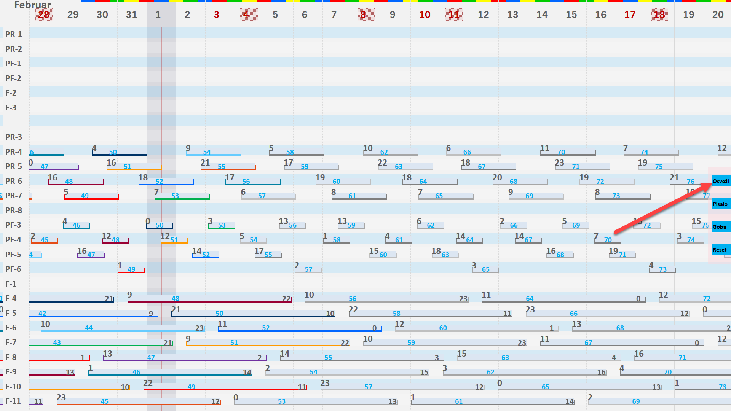

Crating the Excel file
You can do it by hand, but this approach is slow.
With a excel form:
- Open FormaZaPlan.xls
- Click the “From Demo” button 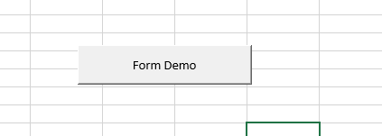
- Click the “Nalozi plan iz datoteke” 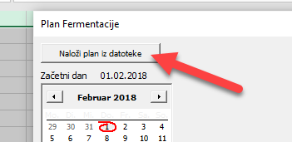
- Select a excel-file with appropriate file structure 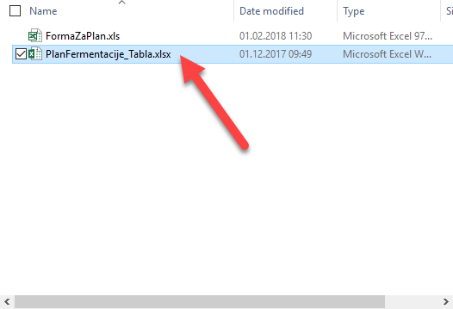
- Select appropriate date, e.g. 21. 12. 2017 in the date picker 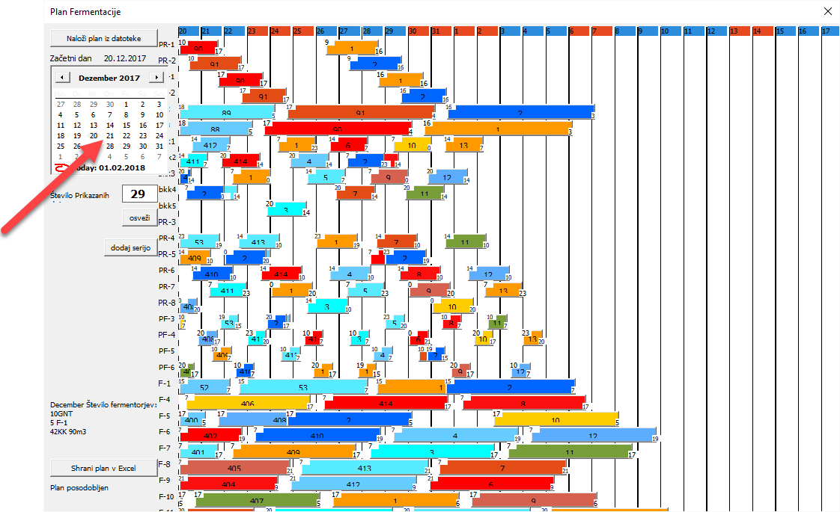
- Add new batch 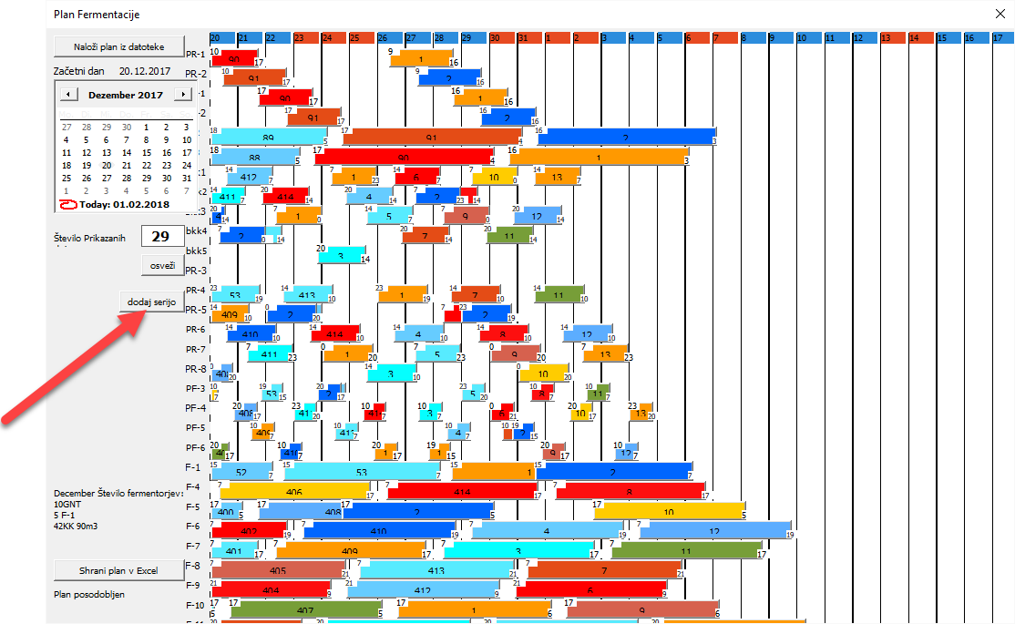
- Select product 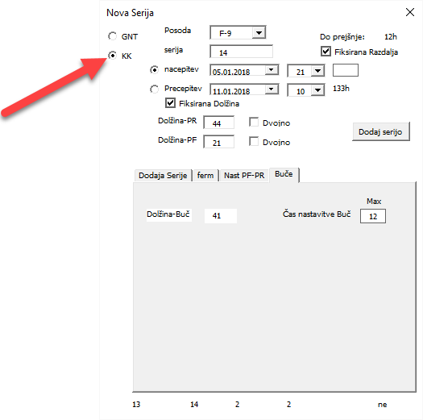
- Click the “dodaj serijo” button to add a series 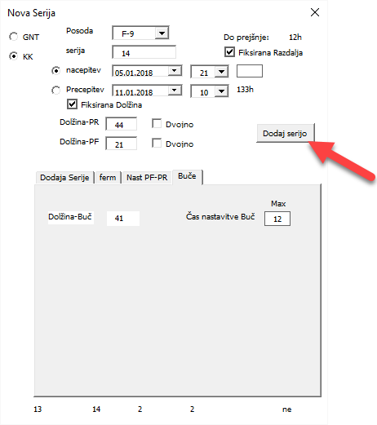
- Close the dialog box 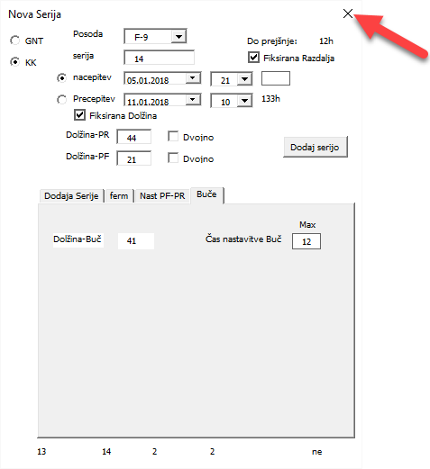
- Export new plan to Excel 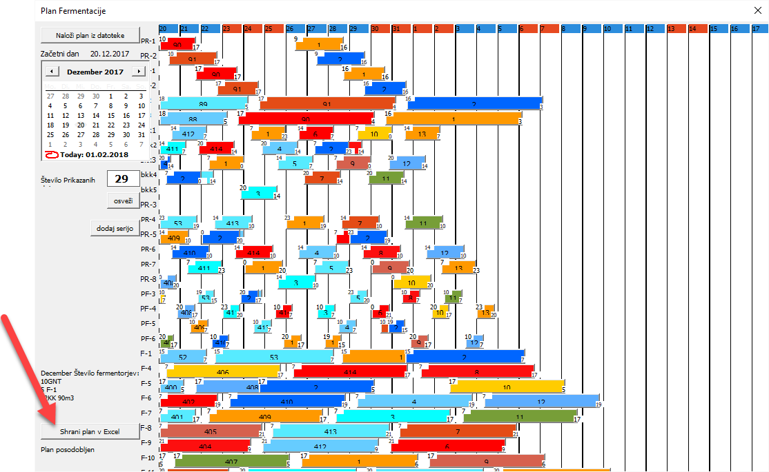
- Save the file 